**DISPLAY AND ARDUINO DIAGRAM**

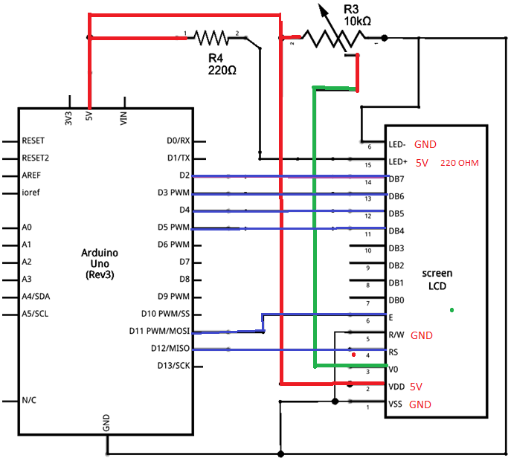

**ARDUINO WITH MOISTURE SENSOR**

**AND RELAY TO MAGNETIC SOLENOIDE**

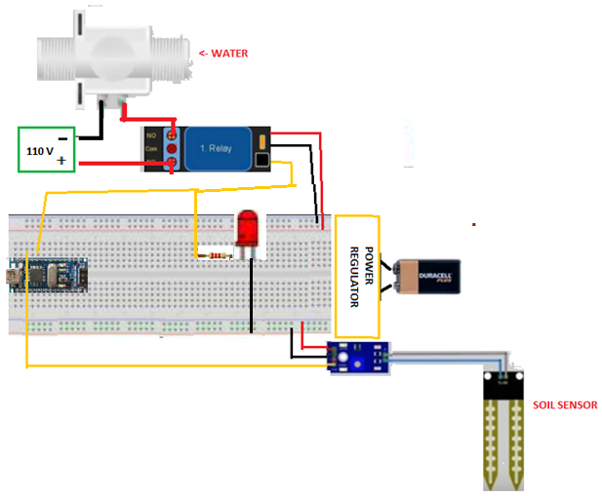

#include <LiquidCrystal.h>

LiquidCrystal lcd(12, 11, 5, 4, 3, 2);

// 300~700   humid soil

// 700~950    in water

int RELAY = 5; // D5

int SENSOR = 16; // A2

void setup() {

pinMode(RELAY, OUTPUT);

pinMode(SENSOR, INPUT);

}

void loop() {

int leer = analogRead(SENSOR);

// [map(value, fromLow, fromHigh, toLow, toHigh)](http://www.arduino.cc/en/Reference/Map)

int humedad = map( leer, 0, 950, 0, 100) ;

String valor="DRYNESS "+String(humedad)+ " %";

//String valor = String(leer);

lcd.begin(16,2);

lcd.print(valor);

delay(500);

(humedad<60) ? digitalWrite(RELAY, LOW) : digitalWrite(RELAY,HIGH);

// if (humedad < 60) digitalWrite(RELAY, LOW)

// else digitalWrite(RELAY HIGH);

}